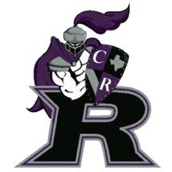
Cedar Ridge
Swimming & Diving
Banquet

Tuesday, April 19th, 2016- 6:30pm
CRHS Small Gym

Athlete - free
Adult - $10
Child - $5 (10 and under)

The Cedar Ridge Culinary Academy will be presenting a Fajita Dinner
for the CRHS Swim and Dive Banquet. There will be beef, chicken and vegetable fajitas available. There will also be a chocolate fountain.

Please return bottom portion of form with $$ by April 7th to Tera Harris 1426 River Forest Dr. There is a black box on the doorstep.
*Please make checks payable to: CRHS Swimming & Diving booster

RSVP by April 7, 2016

Swimmer’s Name_____________________________________

# Total

Adults - $10 (not including swimmer) _____ ________

Children - $5 (10 and under) _____ ________

TOTAL _________

